2016May3 Trading

Experience summary from the previous few months:

1. Apply position only when market shows apparent greed/panic spirit.
2. When T-1 closes low, T presents an opportunity.
3. When T-1 closes high, especially on Monday and Wednesday, T is shortable.
4. When amFirst5 is >0, buying on the dip is allowed.
5. Monday has a linear relation between amFirst5 category and ending percentile. As long as T-1 did not close at a high percentile, the next day is eligible for long.

Be a little careful about where HSCEI opens as it may carry certain information about the foreign market and how US and Japan markets are reacting on a whole.

Last day closed at a pretty low level. There are two competing effects here. One is the effect of the low Friday close has on the first post-weekend trading day, the other is Tuesday's rebound potential.

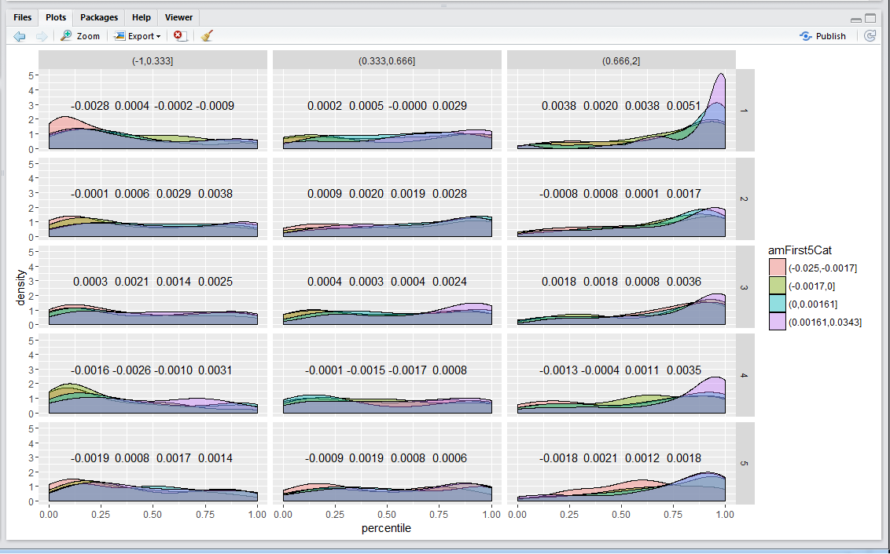

The chart shows that afternoon median retPMCO is correlated with amFirst5Cat.

In the case of

Wanted to short at this level. But research shows that the levels are not attractive. Looking at the results below, afternoon has positive expected return. Sold a bit early.

You see pmCO is positive in all categories of amFirst10Cat.

weekday amFirst10Cat amMaxT1 > 10.25 medCH medCO medAMCO medPMCO

9 2 (-0.037,-0.0021] FALSE -0.0102 -0.0079 -0.0084 -0.0000

10 2 (-0.037,-0.0021] TRUE -0.0046 0.0031 0.0016 0.0013

11 2 (-0.0021,0] FALSE -0.0049 -0.0023 -0.0037 0.0004

12 2 (-0.0021,0] TRUE -0.0036 0.0024 0.0017 0.0016

13 2 (0,0.0021] FALSE -0.0041 -0.0002 -0.0016 0.0022

14 2 (0,0.0021] TRUE -0.0035 0.0043 0.0035 0.0019

15 2 (0.0021,0.032] FALSE -0.0044 0.0039 0.0015 0.0020

16 2 (0.0021,0.032] TRUE -0.0029 0.0098 0.0078 0.0039

Markets have been in low vol region for a while.

Today first 5 and first 10 were both down, reducing the potential for an all-day bull. However, the retPMCO is positive so this discredits shorting. The space for retCH trading is very limited.

Shorting in general:

Lines marked in red are shortable. One can see that they are mostly scenarios where amFirst10 is in the lowest quantile, or if the day is Thursday. Tuesday is not shortable in any circumstance (like today). This implies that selling was not optimal today (note shorting-selling equivalence). You only sell on the way up and only buy on the way down.

Today's mistake: selling when expected return is positive -> should hold until day's end.

weekday amFirst10Cat medCH medCO medAMCO medPerc medPMCO

**1 1 (-0.037,-0.0021] -0.0084 -0.0060 0.3374 0.3717 -0.0006**

2 1 (-0.0021,0] -0.0046 -0.0003 0.4835 0.5995 0.0005

3 1 (0,0.0021] -0.0028 0.0037 0.6513 0.7464 0.0023

4 1 (0.0021,0.032] -0.0024 0.0123 0.7812 0.8853 0.0039

5 2 (-0.037,-0.0021] -0.0076 -0.0043 0.3243 0.5567 0.0002

6 2 (-0.0021,0] -0.0045 -0.0005 0.4038 0.6055 0.0008

7 2 (0,0.0021] -0.0037 0.0019 0.5056 0.6667 0.0021

8 2 (0.0021,0.032] -0.0037 0.0064 0.5860 0.7468 0.0027

**9 3 (-0.037,-0.0021] -0.0093 -0.0041 0.4285 0.5069 -0.0003**

10 3 (-0.0021,0] -0.0054 -0.0009 0.4218 0.5036 0.0005

11 3 (0,0.0021] -0.0036 0.0026 0.4995 0.7292 0.0023

12 3 (0.0021,0.032] -0.0038 0.0078 0.6119 0.7843 0.0032

**13 4 (-0.037,-0.0021] -0.0105 -0.0063 0.3608 0.3466 -0.0014**

**14 4 (-0.0021,0] -0.0070 -0.0023 0.4717 0.3981 -0.0015**

**15 4 (0,0.0021] -0.0053 0.0002 0.5256 0.4927 -0.0006**

16 4 (0.0021,0.032] -0.0050 0.0046 0.5718 0.7054 0.0023

**17 5 (-0.037,-0.0021] -0.0107 -0.0062 0.3558 0.3401 -0.0035**

18 5 (-0.0021,0] -0.0059 -0.0012 0.3993 0.5076 0.0007

19 5 (0,0.0021] -0.0036 0.0026 0.5513 0.6447 0.0014

20 5 (0.0021,0.032] -0.0048 0.0058 0.5679 0.7281 0.0021

Further:

> xtabs(retAMCO<0~weekday+percentileYCat+(retOPC>0))

, , retOPC > 0 = FALSE

percentileYCat

weekday 1 2 3

1 61 71 118

2 76 48 105

3 87 54 87

4 80 52 106

5 60 56 120

, , retOPC > 0 = TRUE

percentileYCat

weekday 1 2 3

1 82 50 32

2 146 34 33

3 113 41 39

4 116 41 33

5 92 40 49

The above two table illustrate the circumstances around which retAMCO<0. When index opens high, if yesterday's closing percentile is positive, the morning session is more likely to have a negative session. Tuesday has a stunning 70% of negative AM return chance if Monday closes in the highest percentile. Thursday has a 61% chance of having a down morning.

The situation is not that clear when the index opens low.

> xtabs(retCO<0~weekday+percentileYCat+(retOPC>0))

, , retOPC > 0 = FALSE

percentileYCat

weekday 1 2 3

1 46 60 99

2 76 43 68

3 90 44 65

4 100 54 88

5 61 43 94

, , retOPC > 0 = TRUE

percentileYCat

weekday 1 2 3

1 74 40 31

**2 127 25 21**

**3 110 35 32**

**4 124 39 23**

5 96 31 46

Above indicates that when T-1 closes in the top percentile, with high probability T will have a negative session in T. Tuesday: 127/173 (73%). Wednesday: 110/(177) (62%). Thursday: 124/(186 = 67%. Friday: 55%. Monday: 51%. Tuesday and Thursday are the most suitable shorting candidates if Monday and Wednesday closed in a high percentile.

Markets are trading at a premium with very stable price path. This shows high expectation of the afternoon session.

The sell was at 10:04 in the am session. Was this appropriate?

Afternoon strength: This graph is median(max|max>t) – median(min|min>t). Tuesday's rebound strength is pretty amazing.

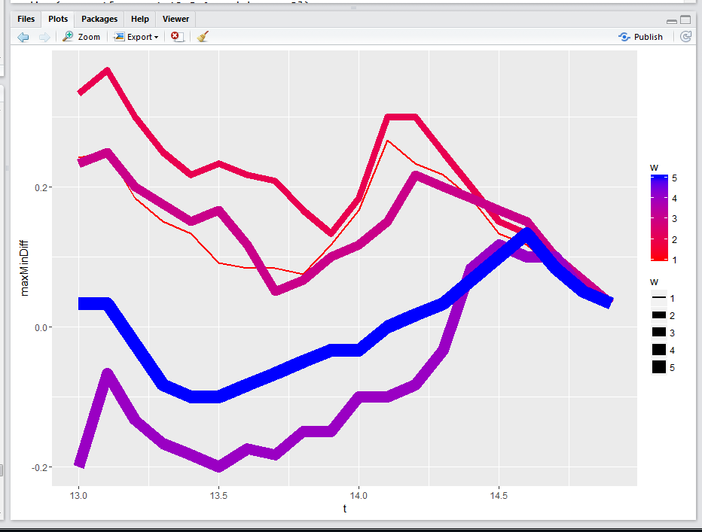

Afternoon max time/mintime. Thurs and Fri are weak.

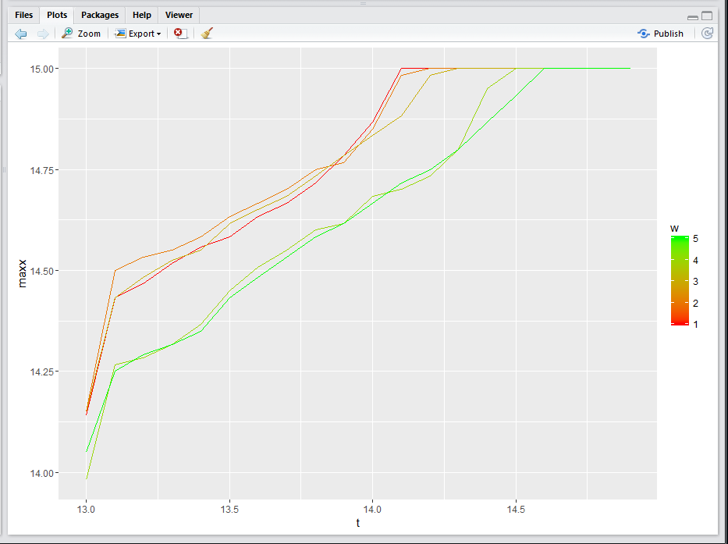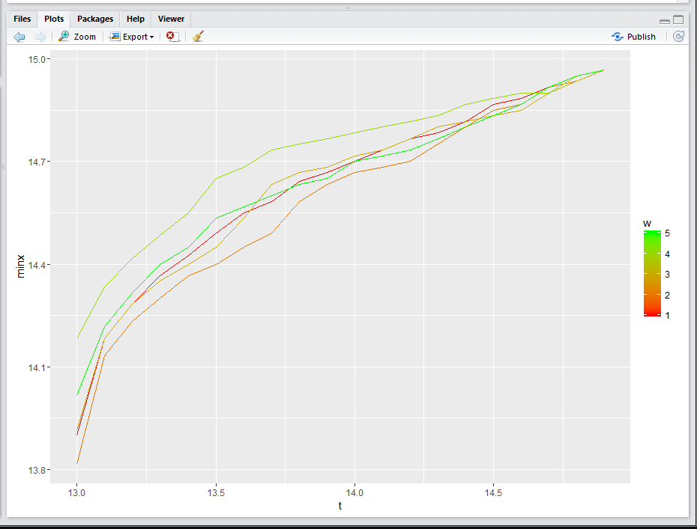

AM session:

Max-min diff: This shows that Tuesday is the weakest Am session and it loses right from the start. For Monday, max has an advantage over min. Weakness ranking: Tue<Fri<Wed<Thu<Mon.

(Need conditioning on the percentileYCat)

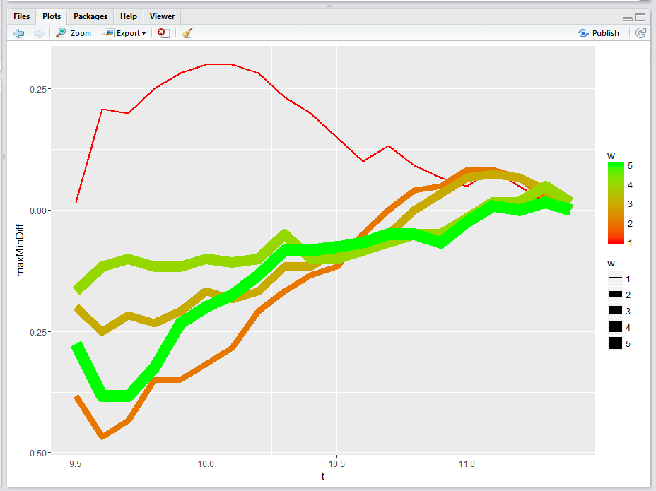

Max/Min: Monday shows as the strongest in both max and min charts.

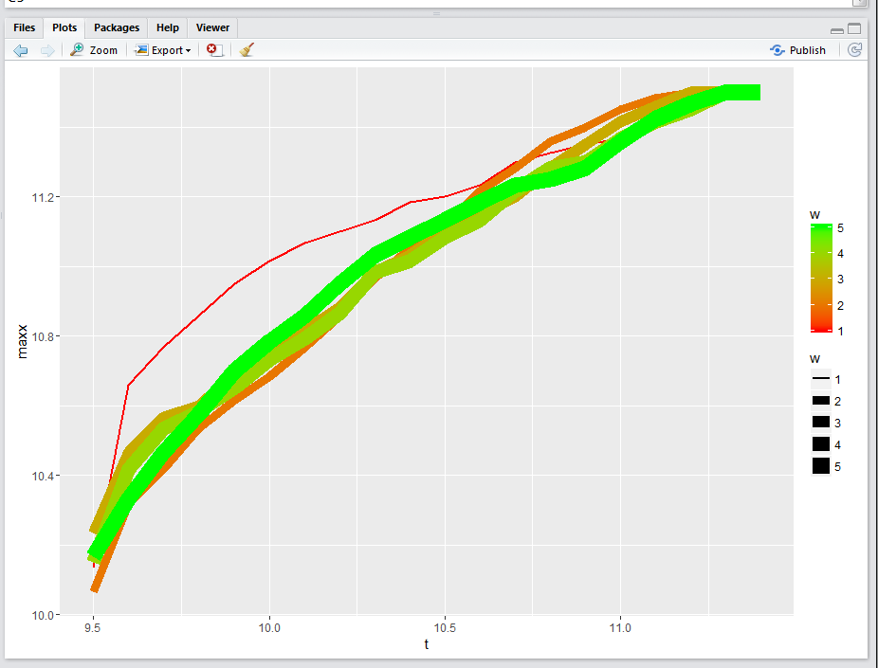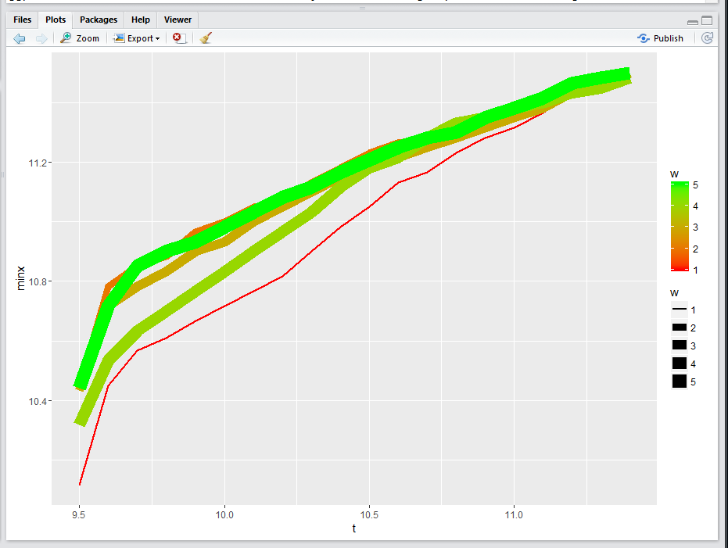

Today's session was strong. The selling in the AM was faulty. Wait until the beginning of next half session to trade. This was an unusual Tuesday partly due to a closed Monday and the fact that it is the beginning of the month. Due to liquidity concerns, it might be possible to explain for the crash effects.

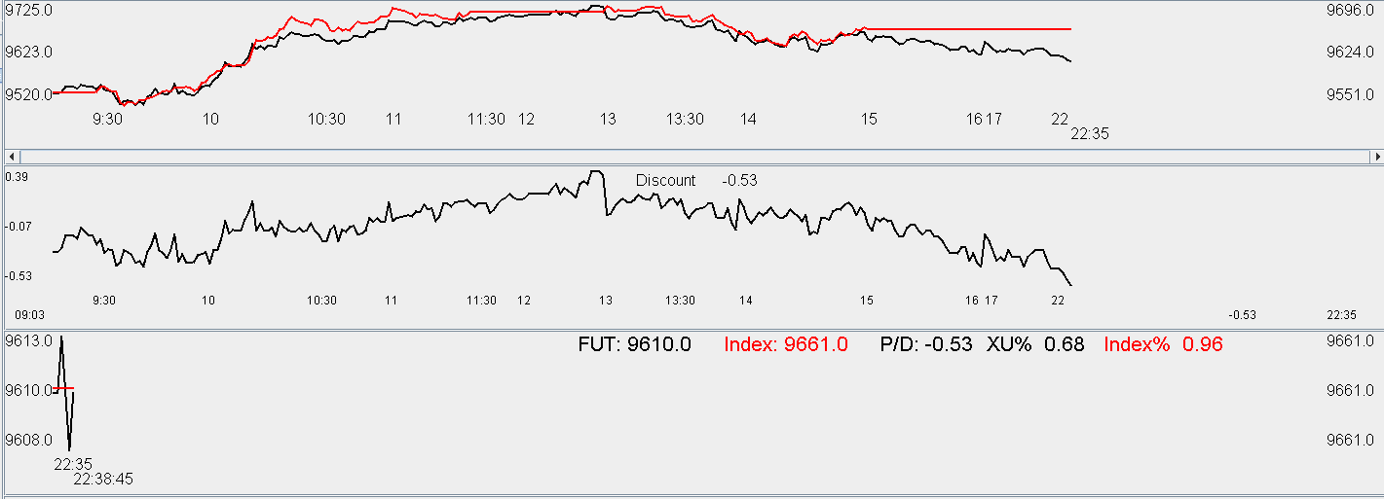

Thurs:

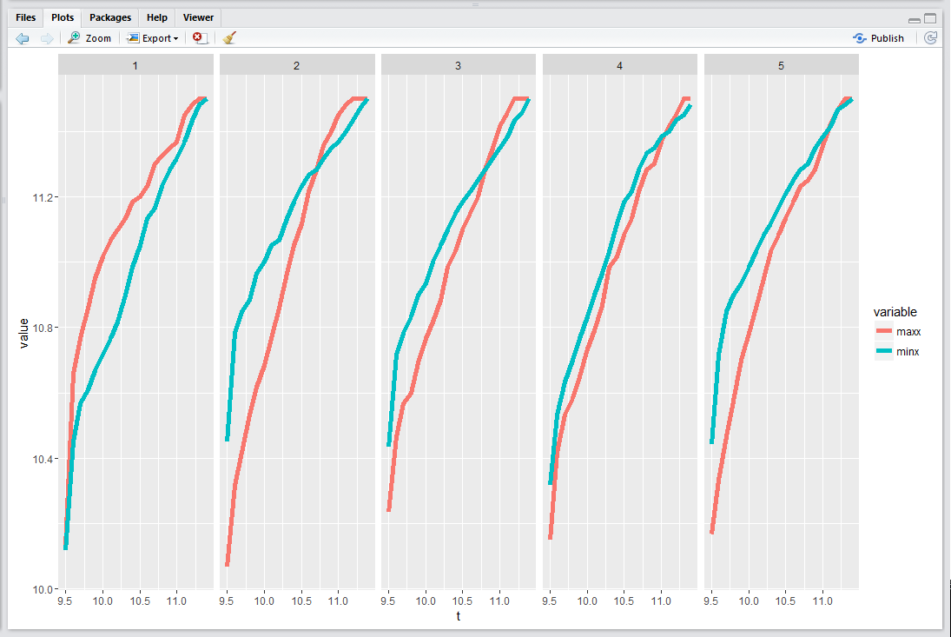

The above graph shows the conditional median of amMaxT1[amMaxT1>x] and same for amMinT1. One can see that unconditional and conditional min tends to come after the max, showing the weak nature of the AM session.

For PM:

x axis is broken down into weekday, y axis is broken down into amCLosePercentile (HML). The two ines are conditional median of the pmMax and pmMin, x being the max/min value happening past t.

One can see that on Monday, a strong AM session helps the pm session.

On Tuesday and Wednesday, a super weak am session makes it very favorable for a rebound even unconditionally. Tuesday and Wednesday PM opening is quite crucial when AM closes high. A strong opening is necessary for the positive PM session but unconditionally market tends to reverse in the PM.

Thurs:

When am closes low, pm is unconditionally weak, but gets weak very quickly if PM keeps dropping. When am closes high, pm is still unconditionally weak until you arise past 13:30. For a day like today PM will very likely underperform.

Friday:

Unconditionally, Friday is weak in both am high and am low scenarios. A strong PM opening will help a strong AM session. When am is weak, PM quickly descends into panic if market keeps dropping below 13:15.

Take note of the jolting pattern where line spikes up.

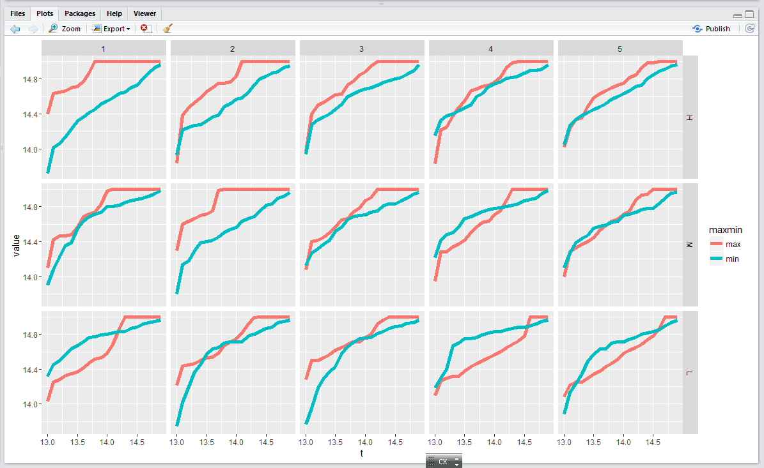

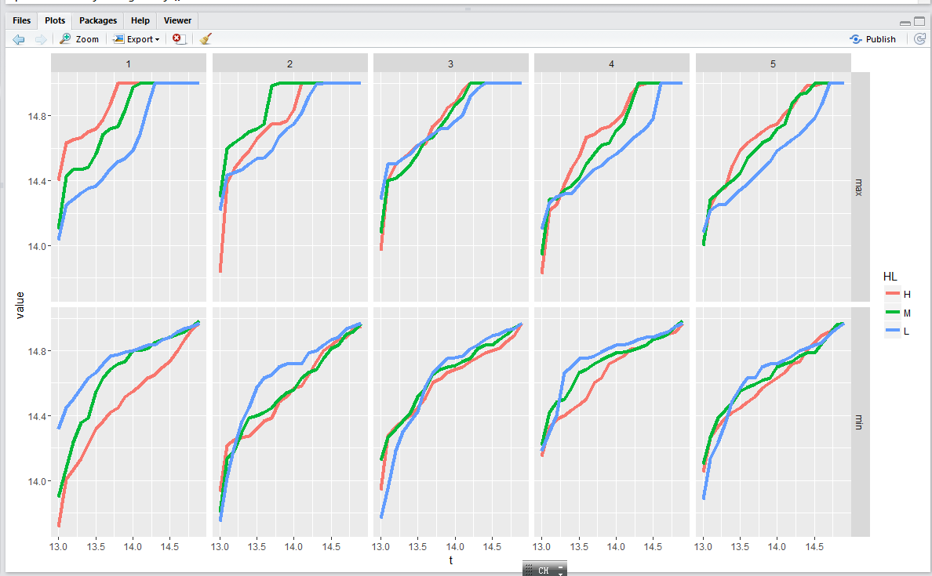

The above graph plots HML by (w~maxmin). Unconditionally, a strong AM hurts Tuesday and Wednesday and a weak AM helps Tuesday and Wednesday.

On the min side, for Monday, a weak AM significantly hurts pm. On Tuesday, 13:15 is a dividing line. On Wednesday, 13.5 is a dividing line. On Thursday, 13:25 is a dividing line, and unconditional min is very late.

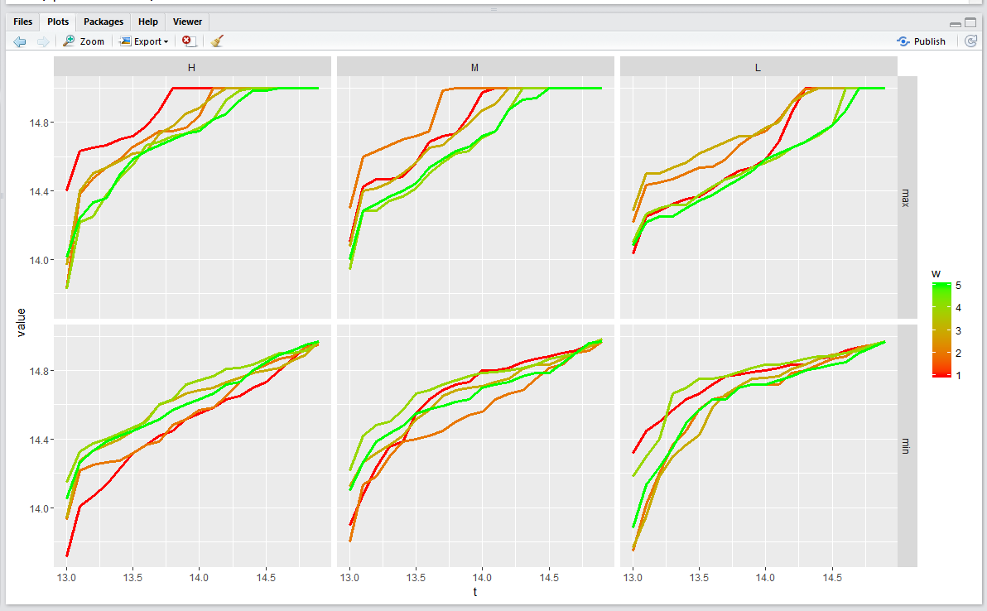

The above graph shows strength by weakness, by HML~ maxmin. With a high am close, this helps Monday the most. With a low AM close, this helps Monday and Tuesday. On the min side, Thursday unconditionally and conditionally are both among the worst, where Monday PM is highly dependent on the AM.

When am is weak, wed>Tues>Fri in terms of rebound.

When am is strong,

**Friday, May 06, 2016**

Week amSession. The median is basical

First 10 minute up while first1 and first5 is down. Yesterday it closed at the medium percentile. Having two lots here is rather comfortable. Won't add any more. The weak first 5 minutes is taking its tolls. Selling into AM close as median is squeezed into amClose. Afternoon there is a

The return is positive in the afternoon.

Discount went from -0.73 to -0.45 on the expectation of a positive afternoon.

Yesterday it actually closed in the upper percentile.

Weekly review:

**Monday:** Off

**Tuesday:** The sell was too early. Let the position develop a bit.

**Wednesday:**

Volatility was low. One lot was bought in the morning and did not get rid of it in the afternoon.

**Thursday:**

There was no volatility on this day. Sold the position in the afternoon.

**Friday:**

Thursday closed at a high percentile, have to be extra careful. The first buy was to avoid missing out, the second buy was for PM rebound, the third buy at 18pm was for rebound the day after.

One potential issue is that Monday crashes. A weak Friday usually does not bode well for Monday. A 3 lot position is a little heavy.

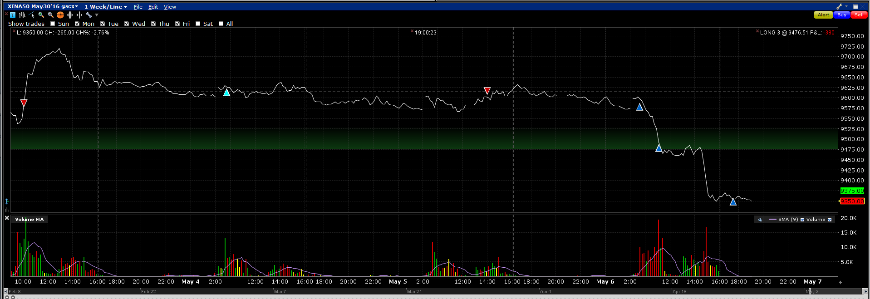

Positives:

Position was light and did not suffer a devastating loss. Buying position was correct on Fri.

Negatives:

10am selling on Tuesday.

Key points from this week:

Morning is weaker than afternoon.

Rebound

这一段时间的求职告一段落. 均已失败告终. 在大岩这, 编程通过了, 不过题答得一般. 包括对最近做的东西的backtesting这块不是很好. 算题的话, 4道里面对了2道,也很一般. 衍生品方面并没问. 简历里面的gap也是有很大的问题. 现在这个状态看来市场是试探性的, 很不是有招人的意愿. 继续下来的是面临转行的问题. 自己做的东西要进行进一步的提高.

看来现在基本在市场认可度方面比较差, 而且公司也不愿意从头培养, 处于一个比较尴尬的状态. 唯一的方式是在自己做的事情上迅速进步才可以. 不用在面试题上花时间, 这本来就是个吃力不讨好的事, 你要复习那么多的题就为了应付一点点题. 投入产出比不划算.

从大摩出来后, 基本就断了继续工作这条路. 简历也比较千疮百孔, 很多事情解释不了. 在大岩这并没有得到任何好的对待, 连汪总都没有见到. 两个手底下的人就可以把我打发. 这就是现在的定位了.

继续做自己做的事情, 这就成了背水沉舟的一战.

因为年龄的问题和这几年资历并没有进步的问题. 处境非常尴尬. 现在面临自己的是转行或者继续读书. 从哥大毕业5年后并没有很好的进展. 事情应该是很顺利的, 很自然的. 如果各种不顺利的话就是做错了事. 这个年纪很尴尬, 还要考虑转行的问题. 全都是问题.

看来这一行并不好混. 到了这个节骨眼上, 退行才是正路.

想想自己以后能干什么作为正业.

自己编程能力不错,智力还行, 继续主攻程序交易这块做一段时间. 但是也要想正业的问题. 给自己多长时间实验现在的东西? 以后的路怎么走? 这都是问题.

最近几个月在投资上进步颇大, 掌握了不少A股的投资技巧, 继续发展一段时间. 毕竟才开始做8个月的时间. 基本可以做到不亏不赚, 对市场的各种分布,了解加深.

为了给自己留一个后路, 今年九月份申请一些学校的统计学博士和法学博士.

这两次面试都拿到说明他们对我的简历感兴趣,想认识一下. 然后最重要的是做的东西并不一致. 大岩做个股, 定增. 我以前的经历是衍生品,现在是机器学习和期货. 他们比较感兴趣的是future rolling的机会, 问的问题有很多是ETF方面的和期货方面的. 问了很多关于分红预测的事情. 衍生品相关的一个没做, 因为他们的专长不是衍生品.

JP那个组就是衍生品交易. 面完了他就觉得你对衍生品并不了解, 其实那是因为这段时间我没有搞那个, 都忘了. 现在等于说我衍生品的领域算丢了, 这是5年的经验. 中国大陆市场的话, 我没做过个股, 他们觉得在我身上找不到什么利用的价值, 因为我的工作经验都是衍生品相关的. 所以他们宁愿找一个可以培训的, 去干苦活累活的. 他们觉得我肯定干苦活累活不行, 毕竟是大地方来的, 他们也装不下. 这就是现在高不成低不就的地方.

下一步,继续做你做东西, 用机器学习的方法, 加强对A股市场的研究, 现在懂这个技术的人不多, 要加快速度. 对条件概率的掌握, 尤其是下午的条件概率分布还要继续增强.

在给自己一年的时间做这个到30岁. 之后做什么？读书浪费时间，钱，精力，要想什么方面可以赚钱．留学顾问可以考虑．

系统性的继续研究．进步速度要加快．

分析转折点．大量分析．利用历时数据挖掘．

从事优势行业，不去做劣势行业．亲近金融，远离金融从业人员．像王健林说的，亲近政府，远离政治．市场是人性使然．既然想超越人性就不能做人群的一部分．

暂时全部停止无谓的求职行为．全部时间花在研究上．做第一批可以用机器学习来搞策略的人．卯足了劲搞这个．看看能走多远．

Quantile regression, 什么都往上干. 把数据挖净. 这是一条不能回头的路.

把R python 精进到非人的程度.

凭什么把自己放在别人的显微镜底下解释自己? 为啥要接受别人的质问? 那个关系是不平等的, 很不舒服, 他可以问很多问题,而且都是在socially acceptable的范围内,因为那是一个面试环境. 我不把自己置身于那种环境当中.

Thinking from first principles, how ridiculous is it to be questioned like a criminal before a panel of judges on one's entire experience and how does it feel to be rejected afterwards? It feels as ridiculous as the experience itself. Why would you put yourself in a position like that? I have been pushed and shoved around a lot in this industry. It is time that I repudiate this period in my life. No more interviews. Interviews operate under the presumption of a judge-criminal relationship – which is in and of itself ridiculous.

Run at full speed these days. Improve even more quickly, massively. Your goal is to control the offshore futures market.

After driving for a few days, driving improved. Running in reverse also helped a bit with driving. Efforts show progress quickly. Massively put in effort and focus all energy on one thing, it will pay off.